**RBFN**

clc;

clear all;

close all;

o=[0 0 1 1;0 1 0 1];

c=[0 0;1 1];

t=[0; 1; 1; 0];

[m1,n1]=size(o);

i=1;j=1;

for i=1:m1

for j=1:n1

C=c(i:i,:);

O=o(:,j:j)';

a=O-C;

a=a.*a;

s=sum(a);

d(i,j)=sqrt(s);

f(i,j)=exp(-(d(i,j)^2));

end

end

for i=1:n1

one(i)=1;

end

fi=[f' one'];%bias 1

w=((inv(fi'*fi))*fi')*t; % pseudo inverse technique to find an inverse of a non-sq matrix

x=[o' one'];

y=fi*w;

scatter(f(1,:),f(2,:));

hold on;

x3=[-4 -3 -2 -1 0 1 2 3 4 5 6 7 8 9];

y1=-(w(1)/w(2))*(x3-1);

axis([-2 2 -2 2]);

plot(x3,y1);

**OUTPUT:**

f=

1.0000 0.3679 0.3679 0.1353

0.1353 0.3679 0.3679 1.0000

y=

0.0000

1.0000

1.0000

0.0000

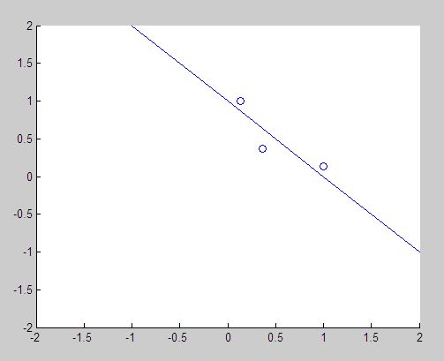

Fig1: Output of RBFN